Assignment 3
Name : Om A. Akiwate
PRN : 255209003
BATCH : BT4

Dataset — Generate It Yourself
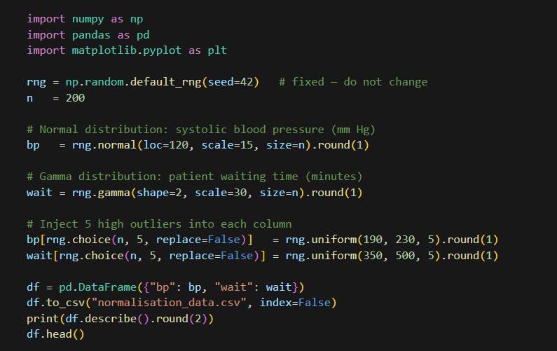
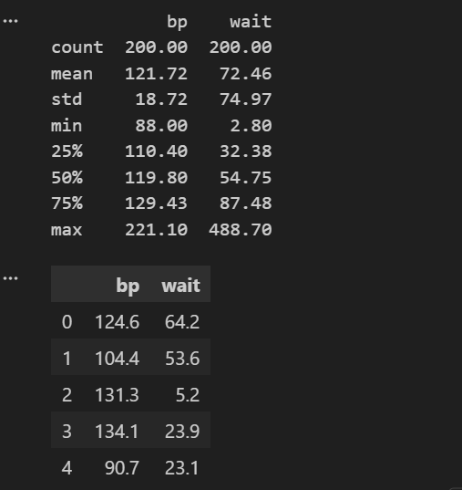

A.2 Python One-Liners for Each Technique Let s = df["bp"] (a pandas Series). Each line produces a new Series — assign it to a variable.
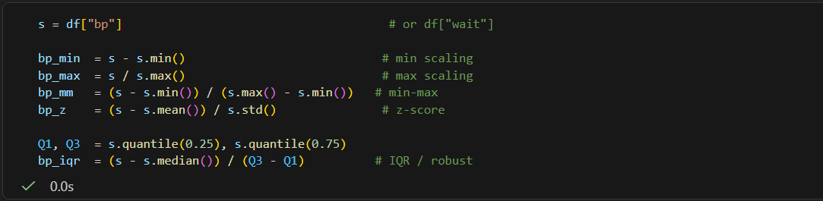
A.3 Plotting: Histogram + Box Plot Side by Side After Each Normalisation Use this template after every normalisation. Replace bp_mm and the title string each time.
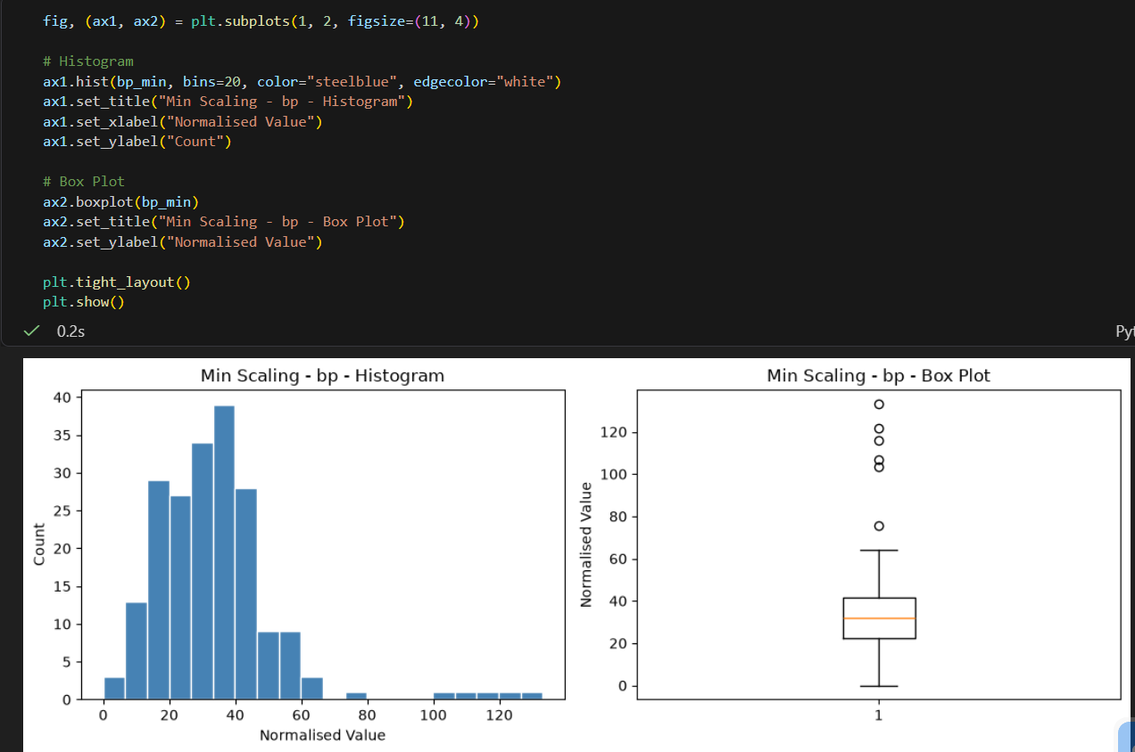
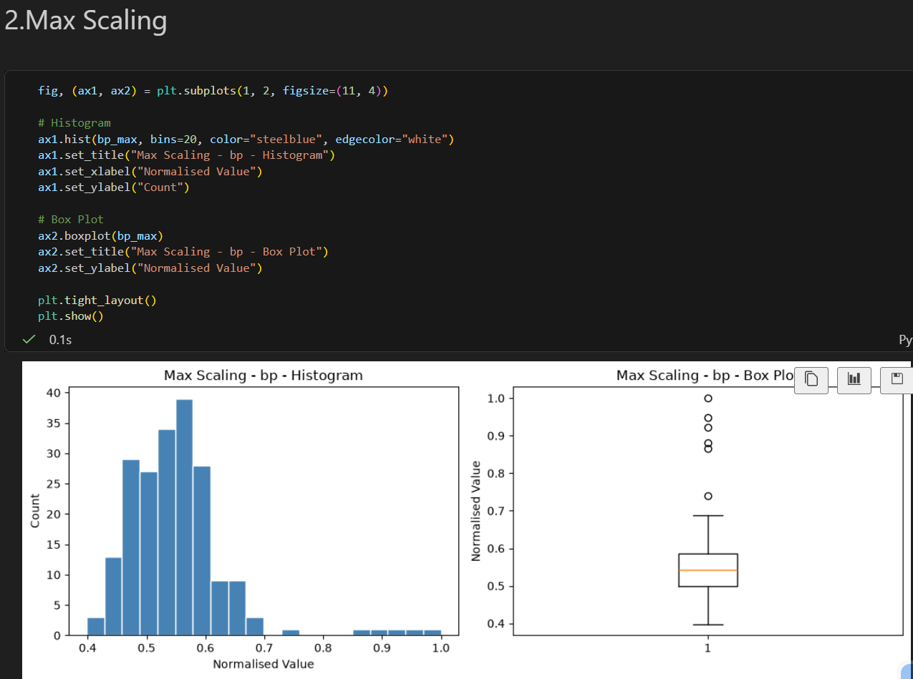
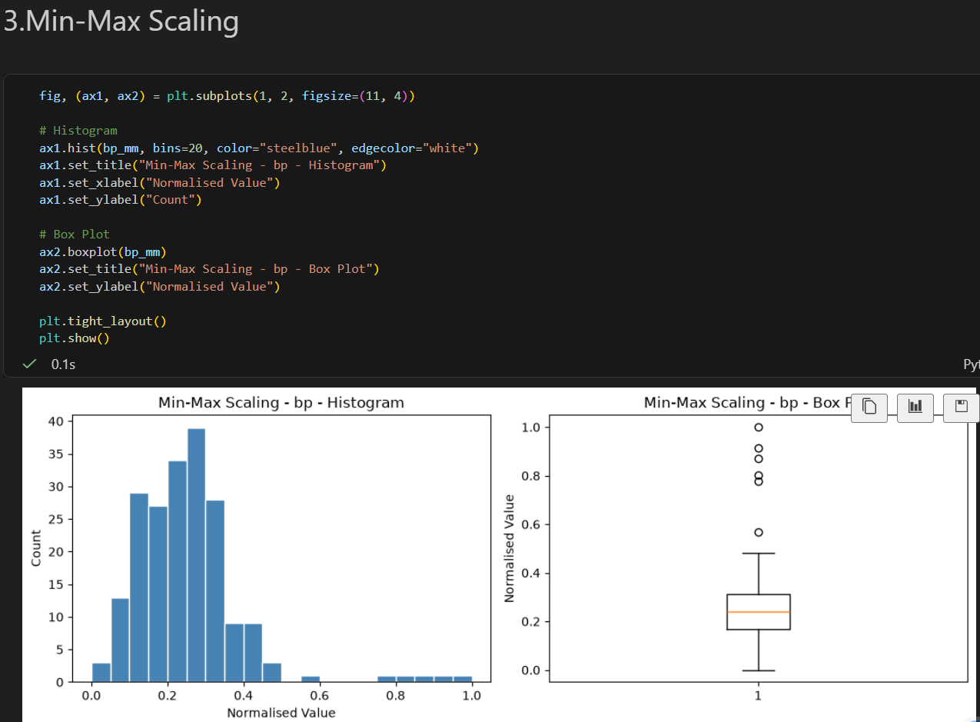
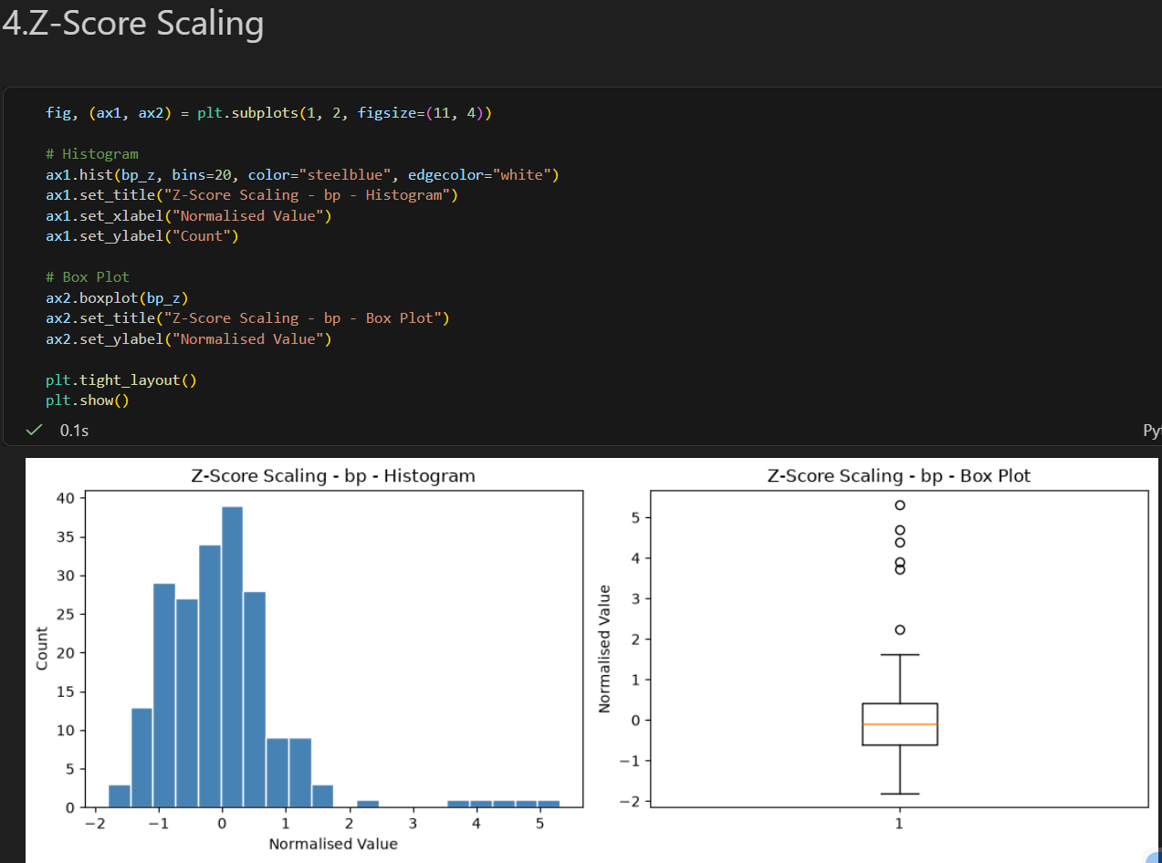
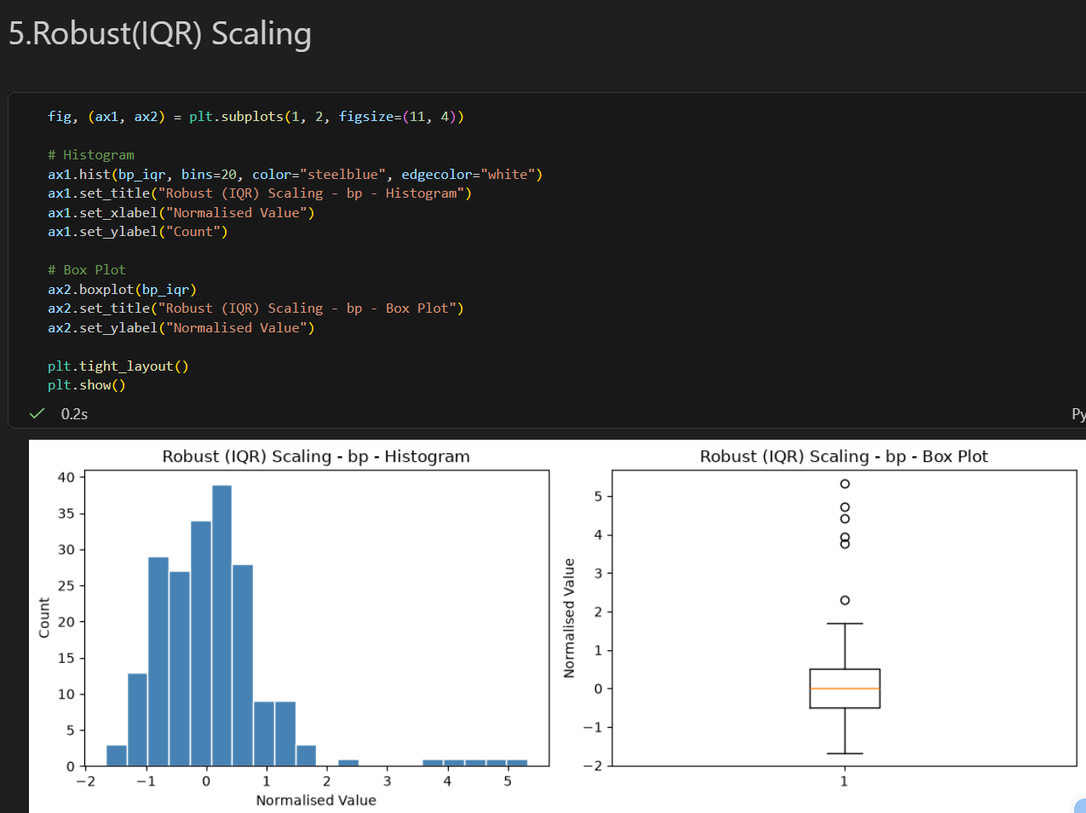


B.1 Generate and Explore the Raw Data
Run the dataset cell from Section 0, then work only with normalisation_data.csv from here on.
B1. Load normalisation_data.csv. Print shape, head, and describe(). In a markdown cell, record for each column: the mean, median, min, max, and whether mean is above or below median. Explain what a large gap between mean and median tells you about shape.

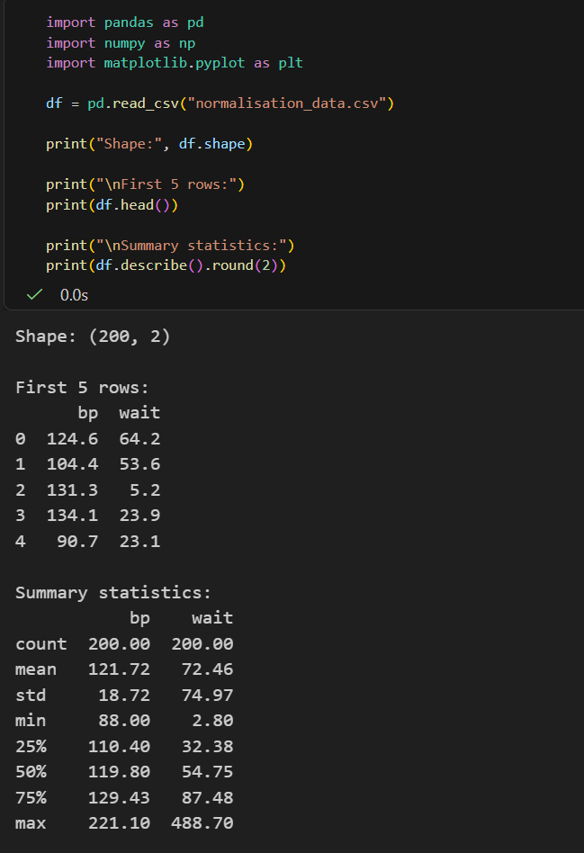

B2. Plot a histogram and box plot of the raw bp column side by side. Repeat for the raw wait column. In a markdown cell, compare the two pairs of plots — which column looks more symmetric, and which shows a longer upper tail? Are outlier dots visible in the box plots?
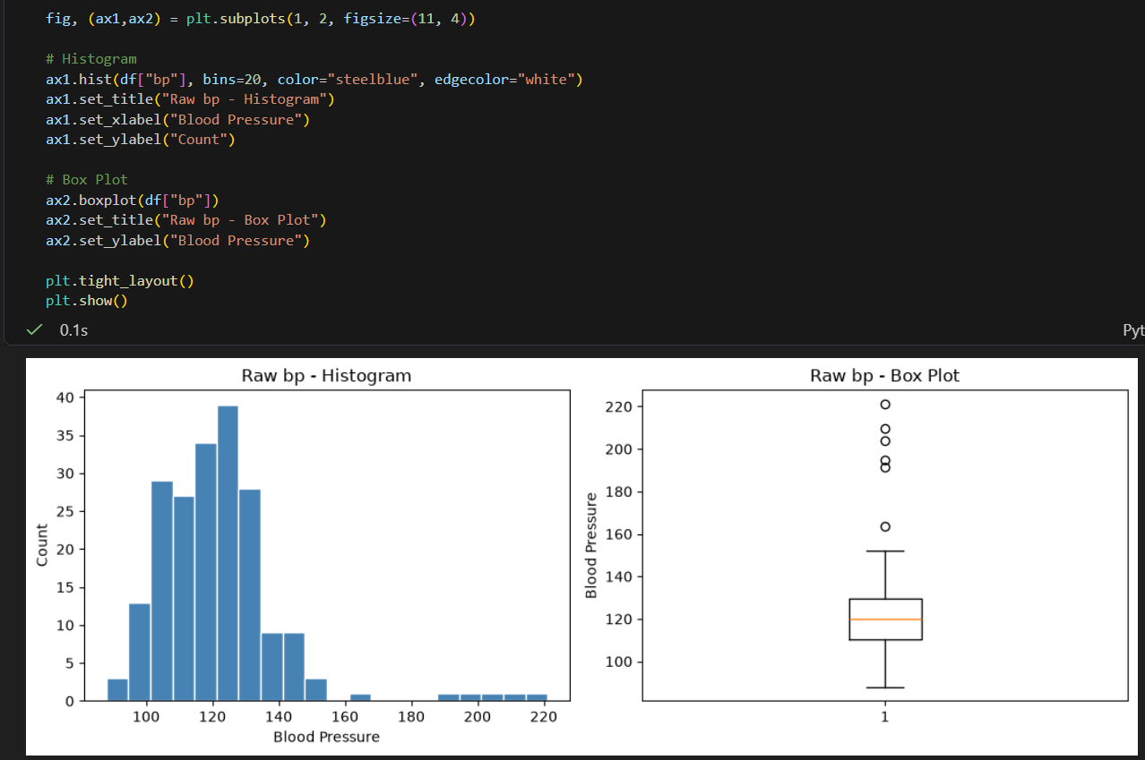
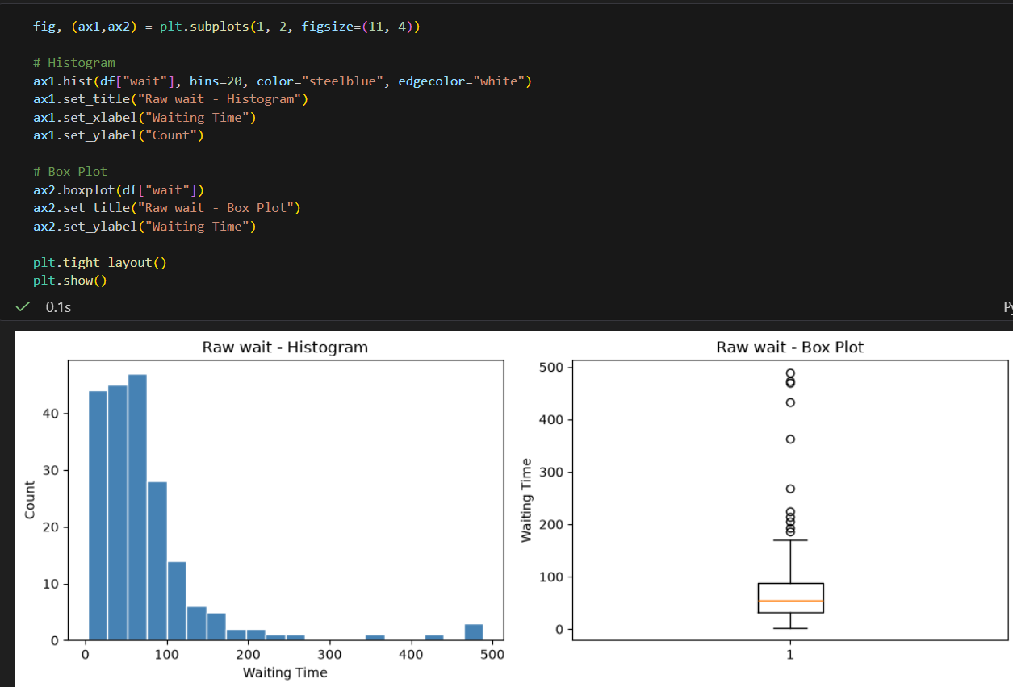

B3. Compute the skewness of both raw columns using pd.Series.skew(). Record the values in a markdown cell and explain what positive skewness means visually. Which column is more skewed, and does that match what you see in the plots?
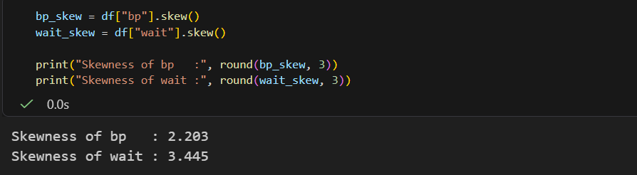
B.2 Min Scaling ( x − min )
B4. Apply min scaling to both columns. Print the min and max of each result and confirm that every minimum is now exactly 0.
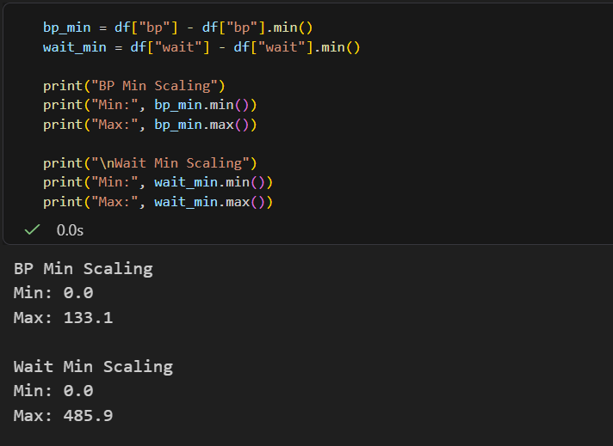

B5. For each column, plot a histogram and box plot side by side (label the technique and column in the title). Write one sentence per column: what changed on the x-axis compared to the raw plots, and what stayed the same
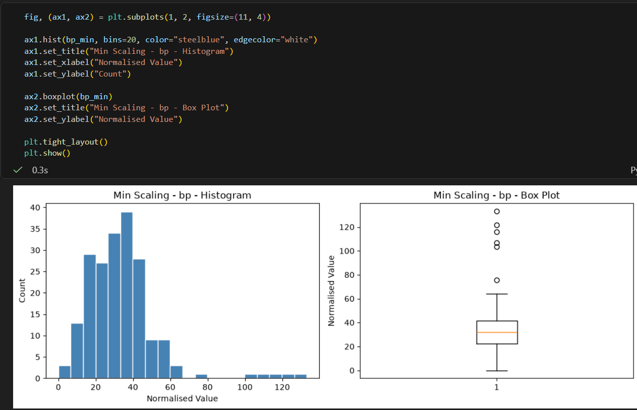
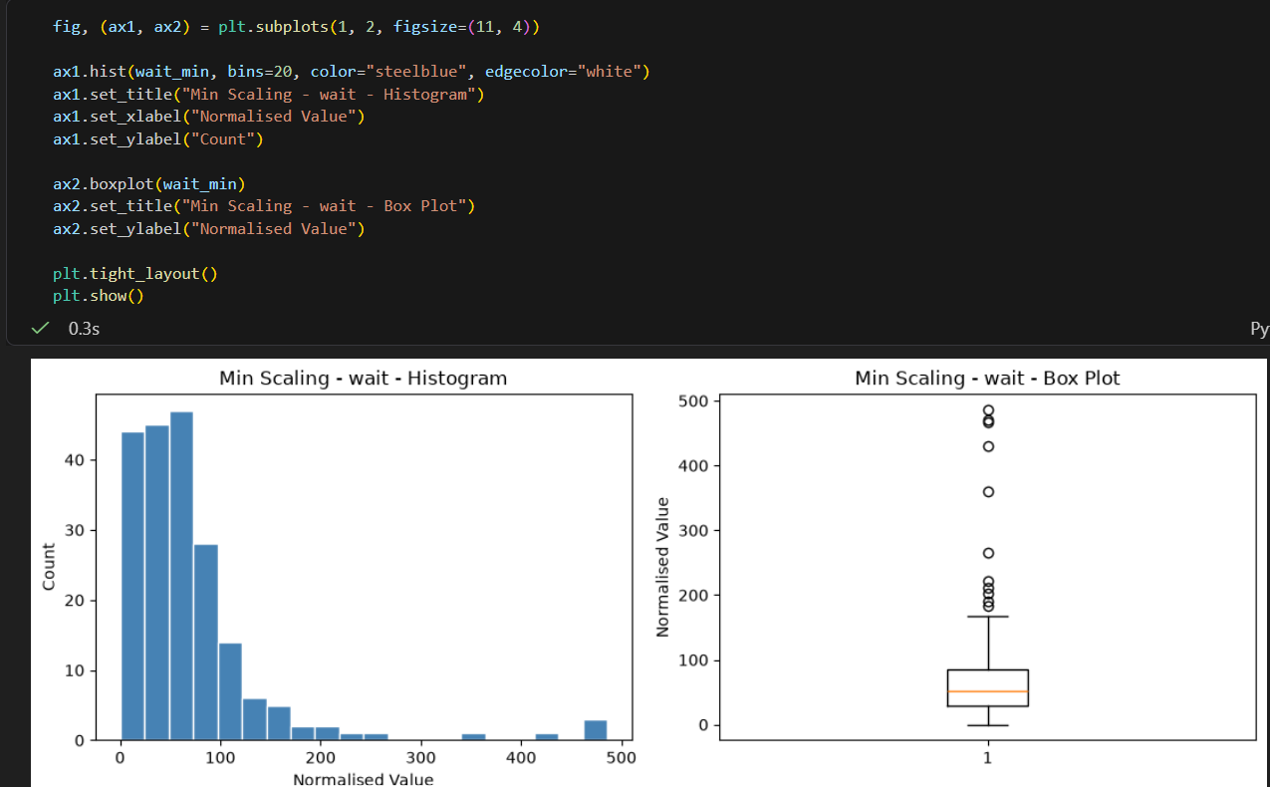


B.3 Max Scaling ( x / max )
B7. Apply max scaling to both columns. Print the min and max of each result. Is the minimum of bp_max the same as the minimum of bp_mm? Why or why not?
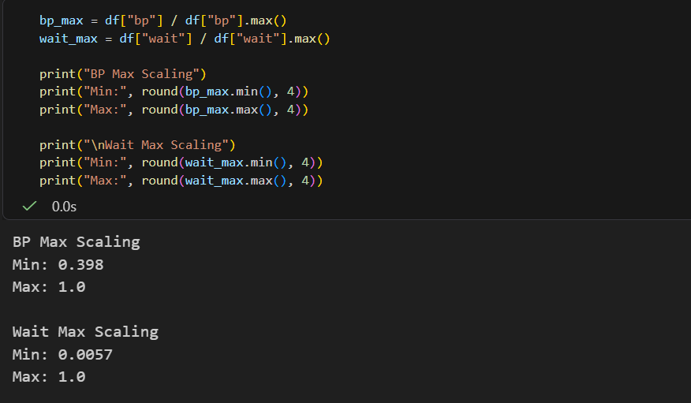
B8. Plot histogram + box plot for each column after max scaling. In a markdown cell, compare these plots with the min scaling plots from B.2: what is different, and why does the minimum of the max-scaled column not equal 0?
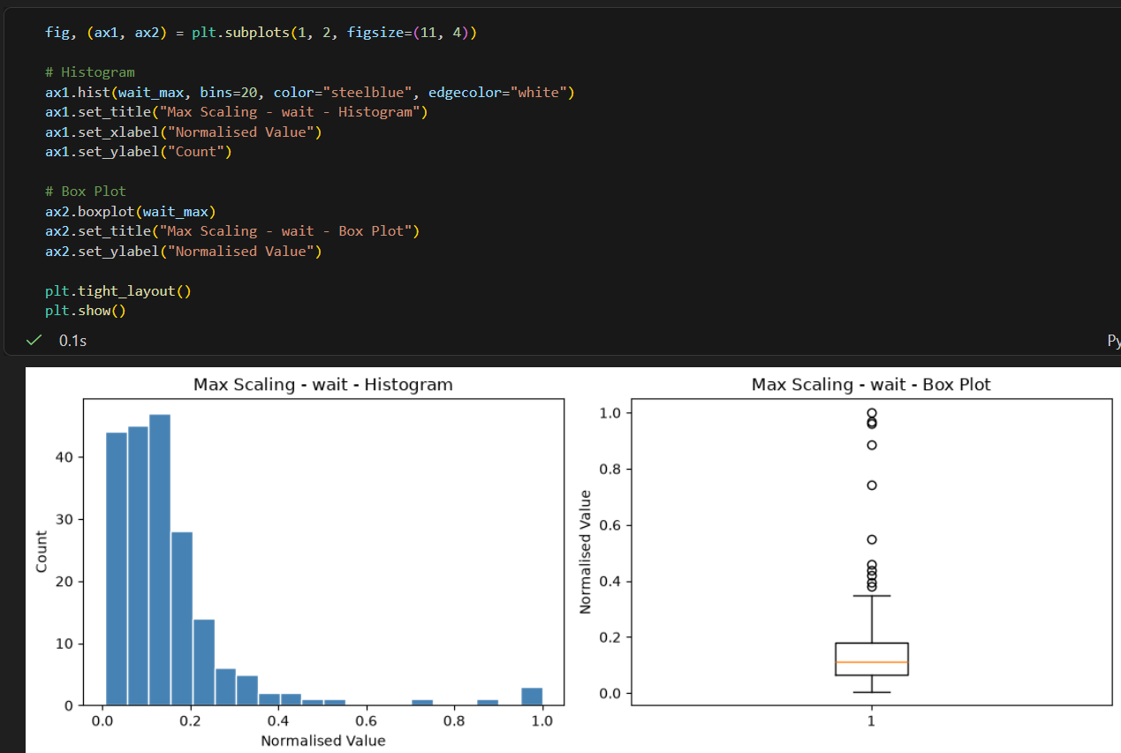
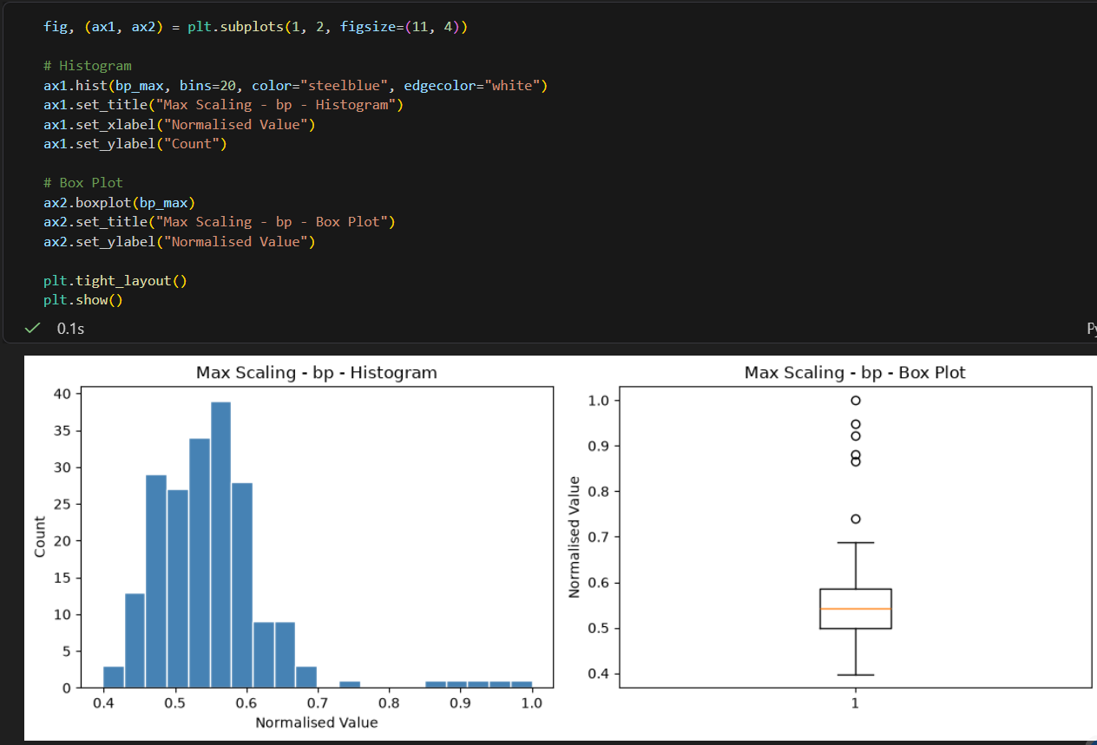
B.4 Min-Max Scaling ( (x − min) / (max − min) )
B9. Apply min-max scaling to both columns. Confirm that every minimum is 0 and every maximum is 1.
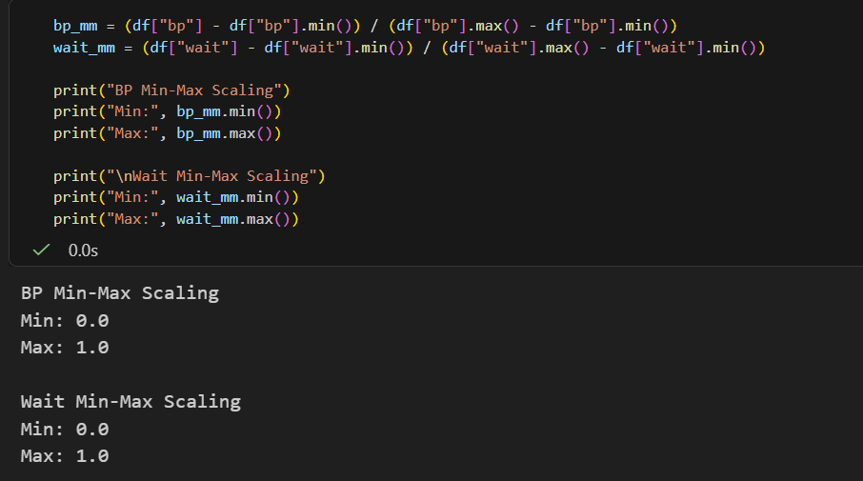

B10. Plot histogram + box plot for each column. In a markdown cell, locate the outlier dots on the box plots: do they look more squashed towards the high end compared with the z-score and IQR plots you will draw later? (Make a note — you will return to this in B.7.)
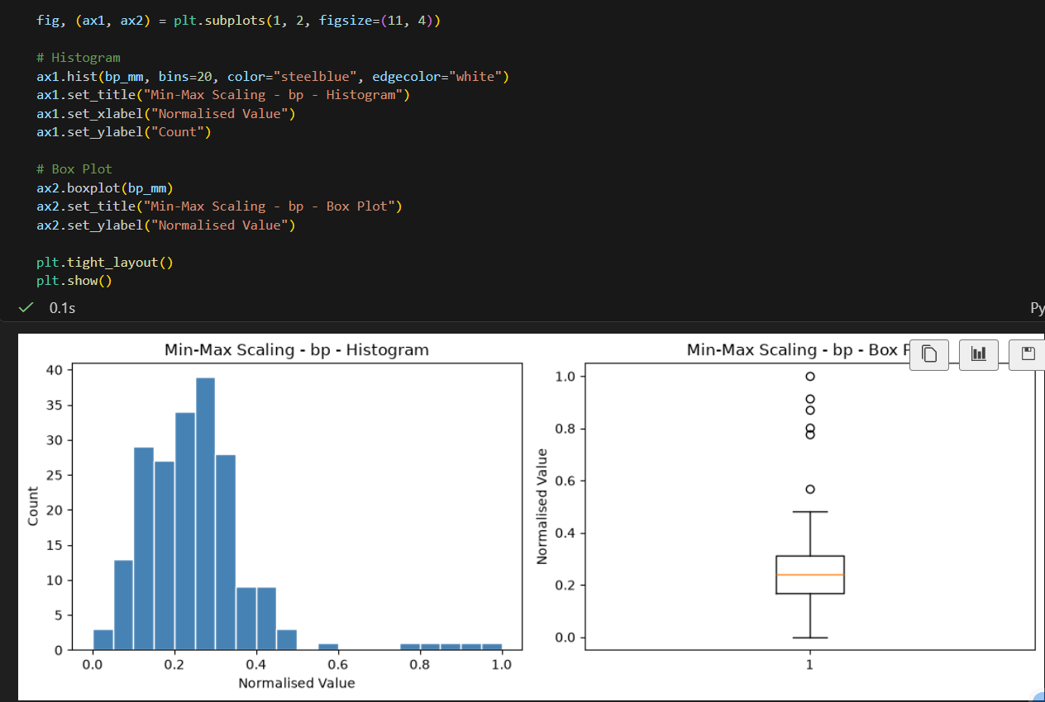
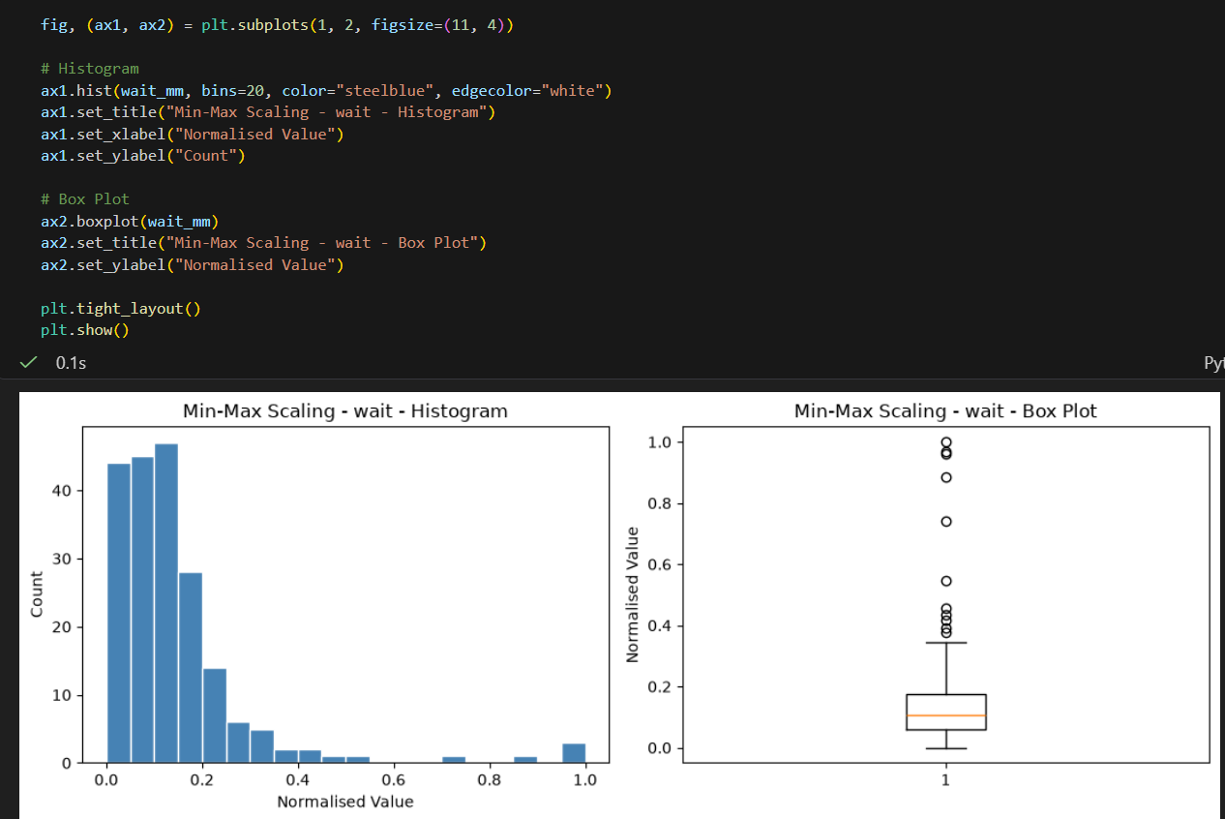
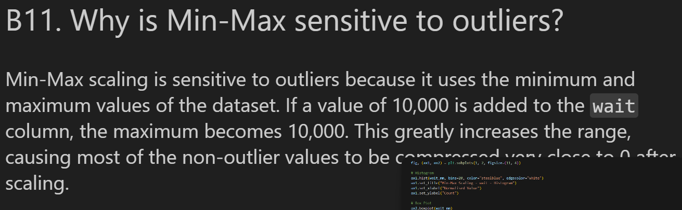
B.5 Z-Score Normalisation ( (x − mean) / std )
B12. Apply z-score normalisation to both columns. Print the mean and standard deviation of each result — they should be approximately 0 and 1. Are they exactly 0 and 1? Why might there be a tiny numerical difference?
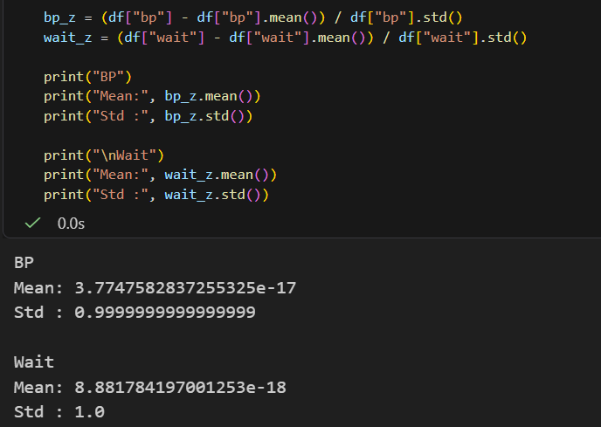
B13. Plot histogram + box plot for each column. In a markdown cell, identify the z-score value of the outliers from the box plot (read off the approximate y-position of the outlier dots). Are any beyond ±3? What does a z-score of +4 mean in plain language?
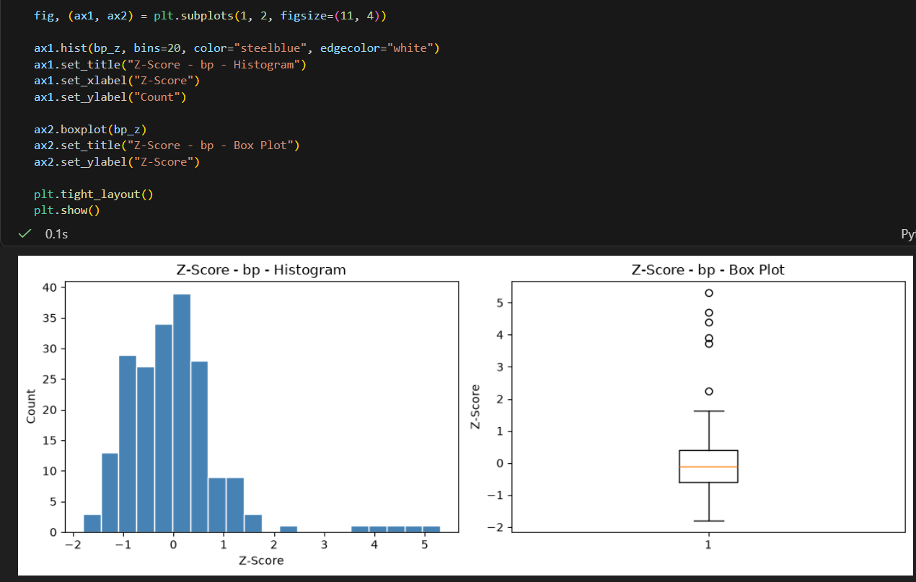

B14. Compare the z-score histogram of bp with its raw histogram from B.1. Write one sentence: how did the shape change, and how did the x-axis scale change?

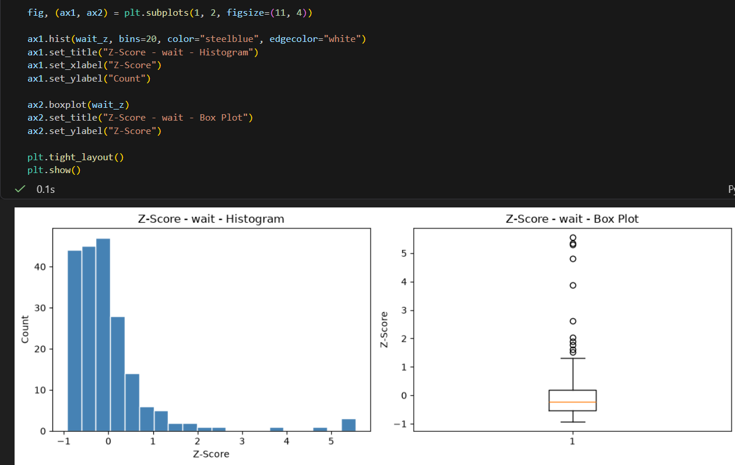
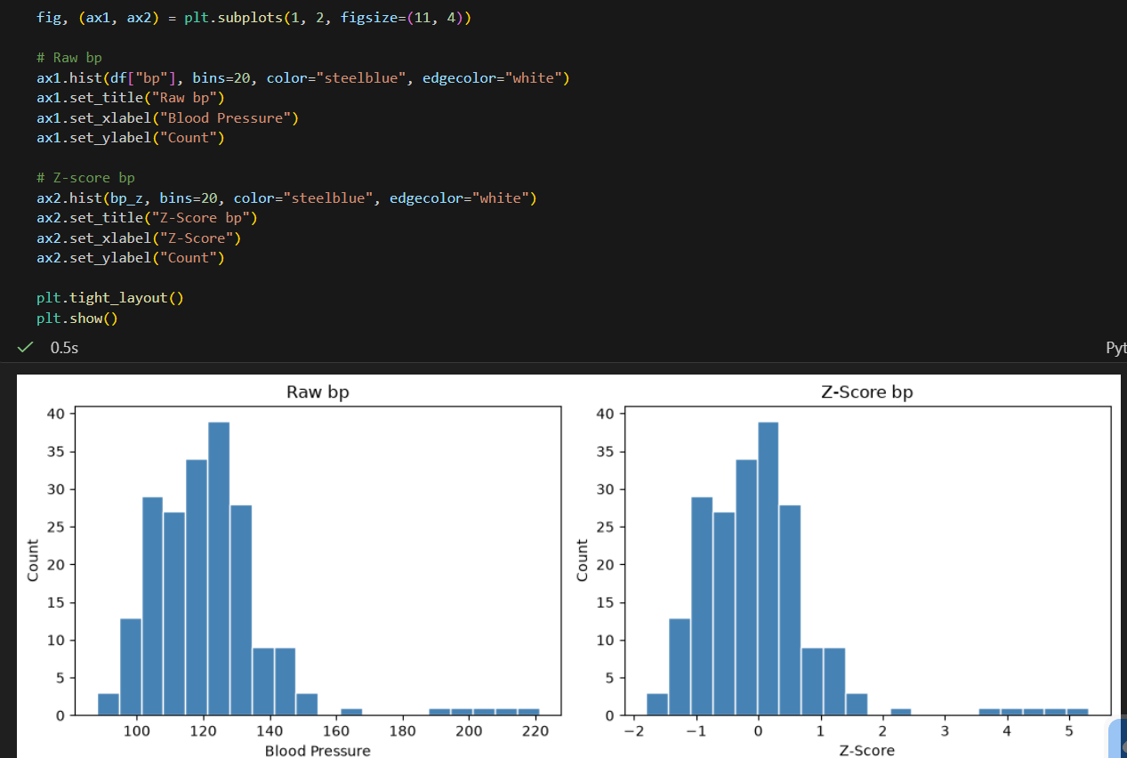

B.6 IQR / Robust Scaling ( (x − median) / IQR )
B15. Apply IQR scaling to both columns. Print the median and IQR of each result — the median of the normalised column should be exactly 0. Verify this.
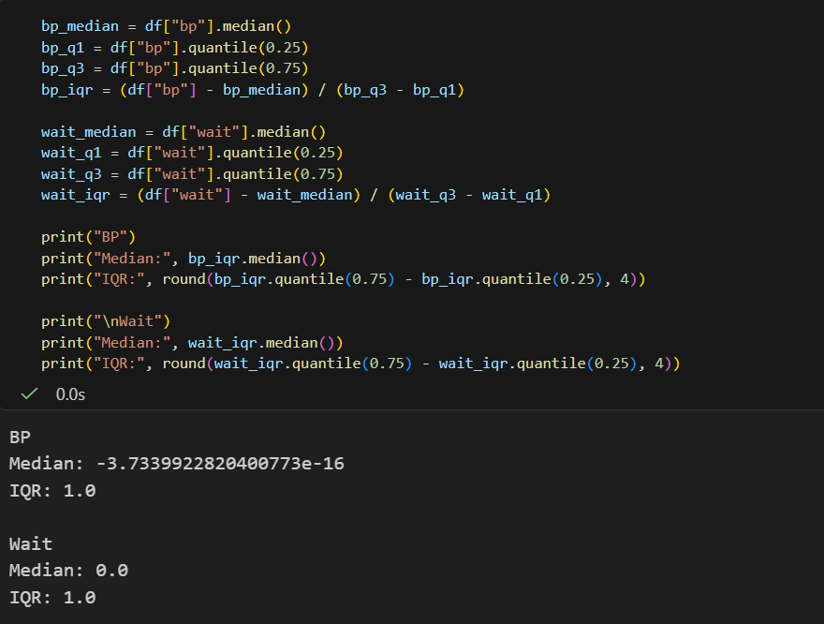
B16. Plot histogram + box plot for each column. In a markdown cell, observe the outlier dots on the box plots: are they farther from the box compared with z-score normalisation? Explain why IQR scaling pushes outliers further out while keeping the main body of the data more compact.
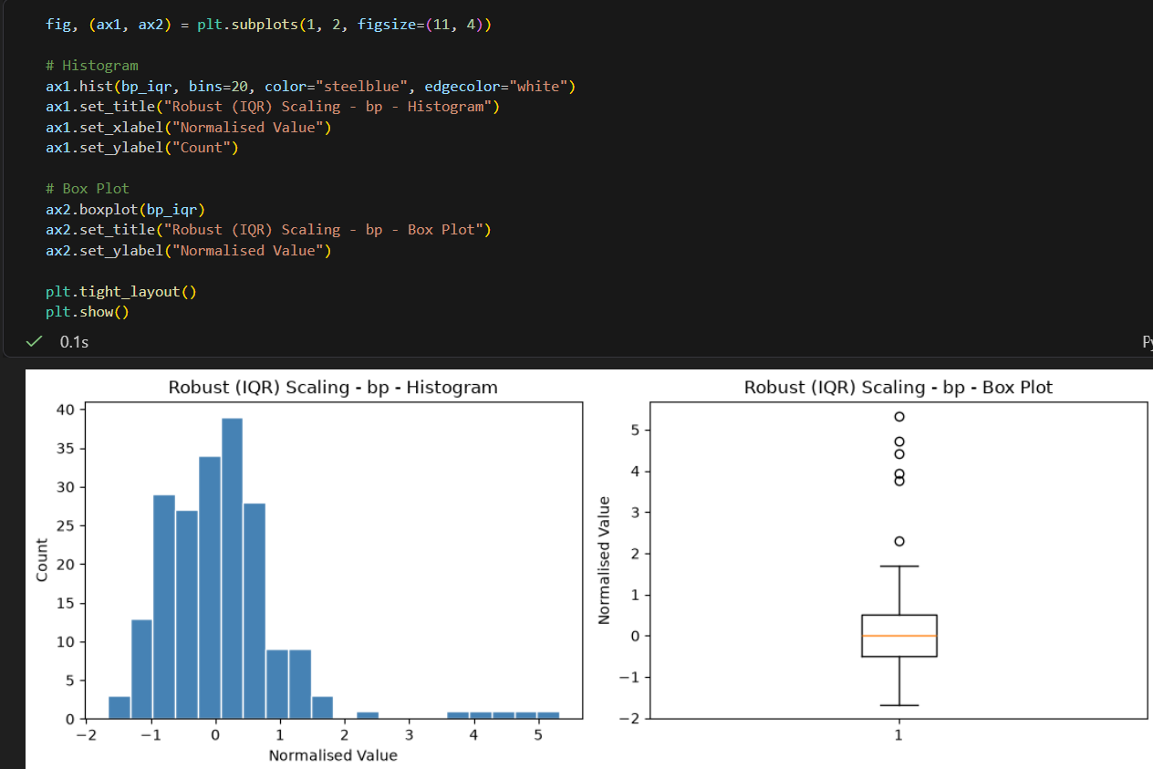
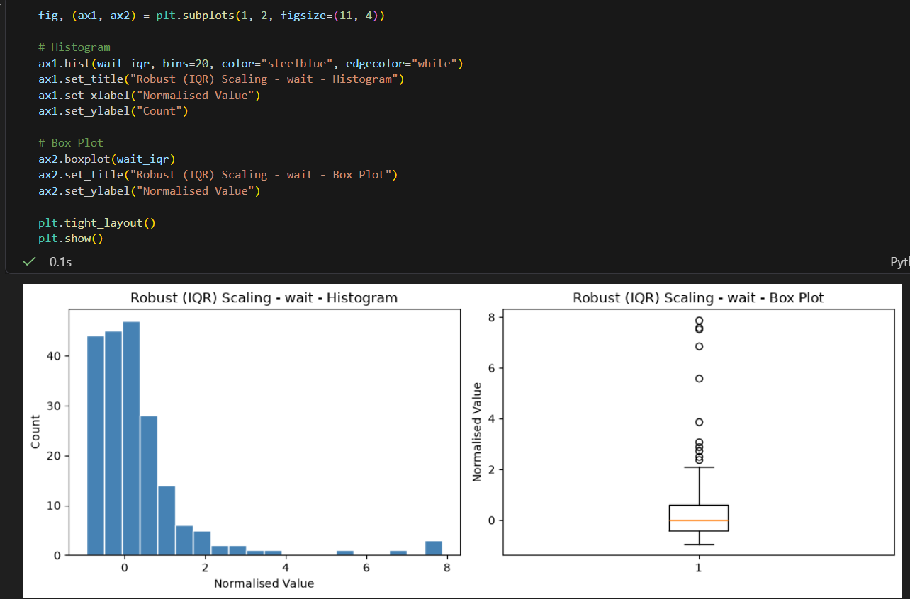
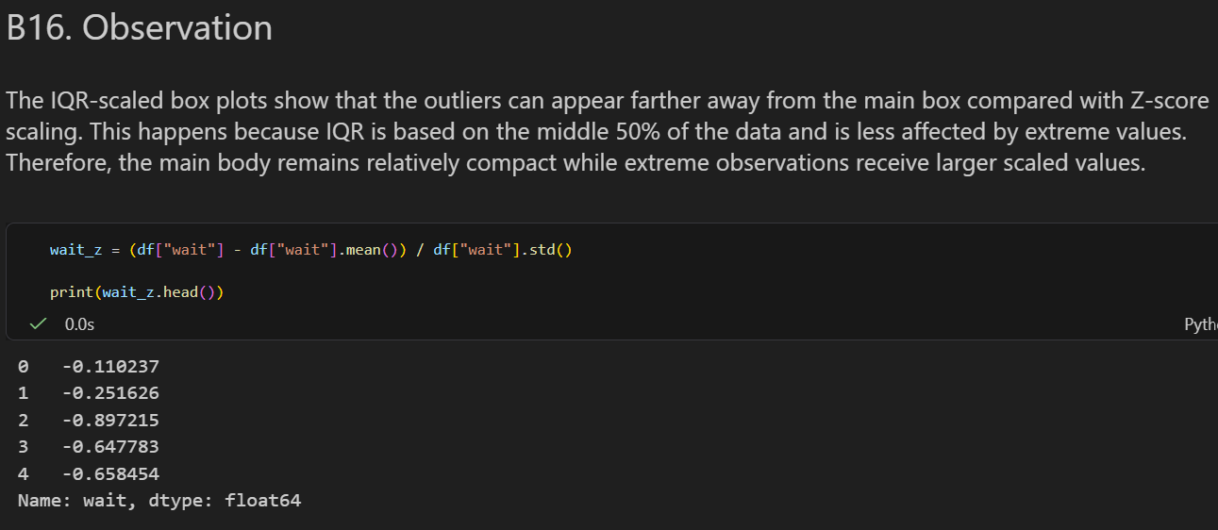

B17. Compare the IQR-scaled box plot of wait with the z-score-scaled box plot of wait side by side. In a markdown cell, state which method you would prefer for a dataset with many extreme outliers and give one reason.
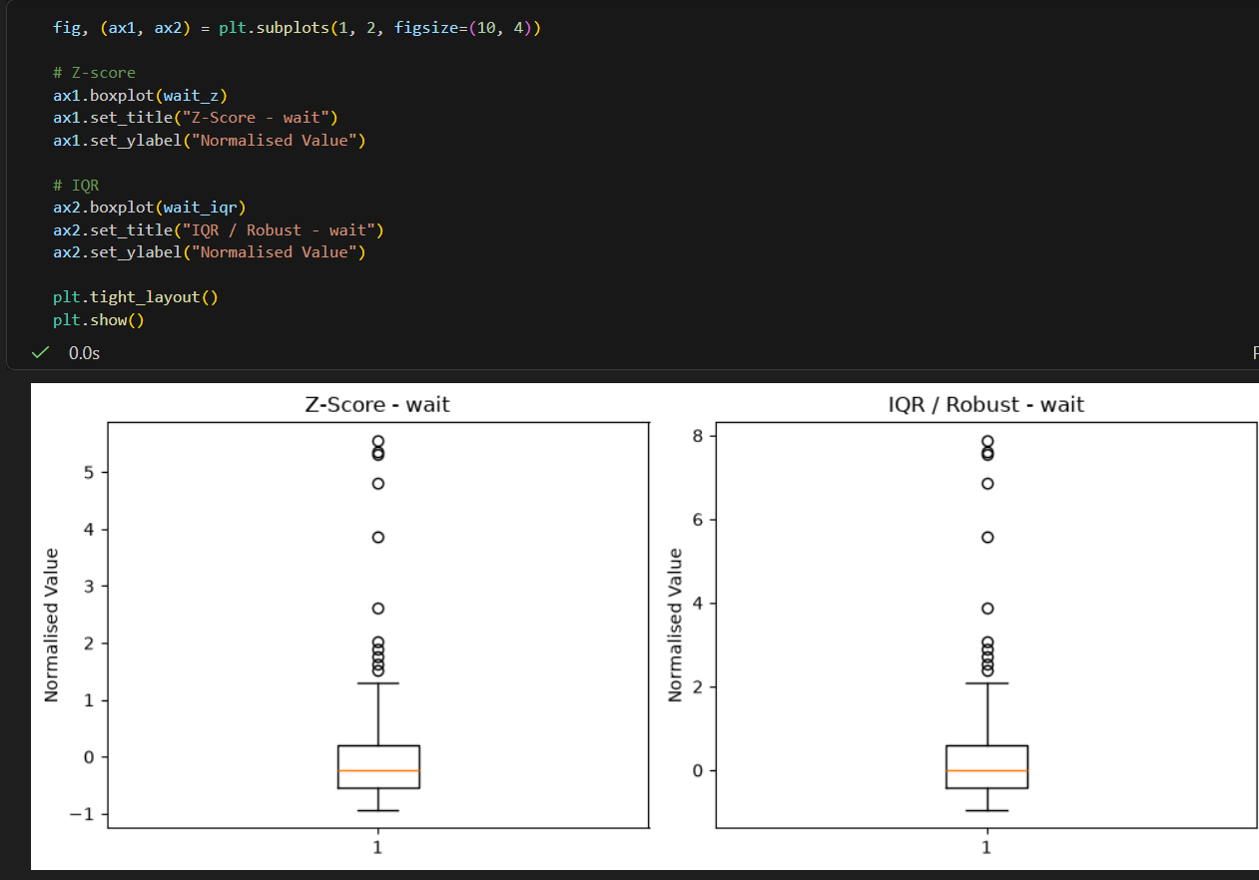

B.7 Summary Comparison
B18. Create a single DataFrame containing the raw column and all five normalised versions of bp. Call describe() on it and print the result. In a markdown cell, fill in this observation table: Technique | min | max | mean | median raw | ? | ? | ? | ? min scale | ... | ... | ... | ... (and so on for all five) Which two techniques produce the same shape with different x-axis scales?
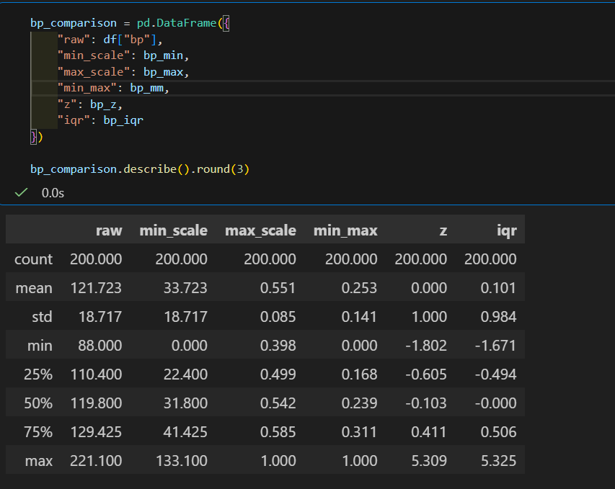
B19. Draw one figure with five box plots side by side — one per normalisation technique — for the wait column. Use plt.subplots(1,5) and label each subplot with the technique name. Write two sentences: which technique most compresses the main body of the data, and which technique makes outliers look the most extreme?
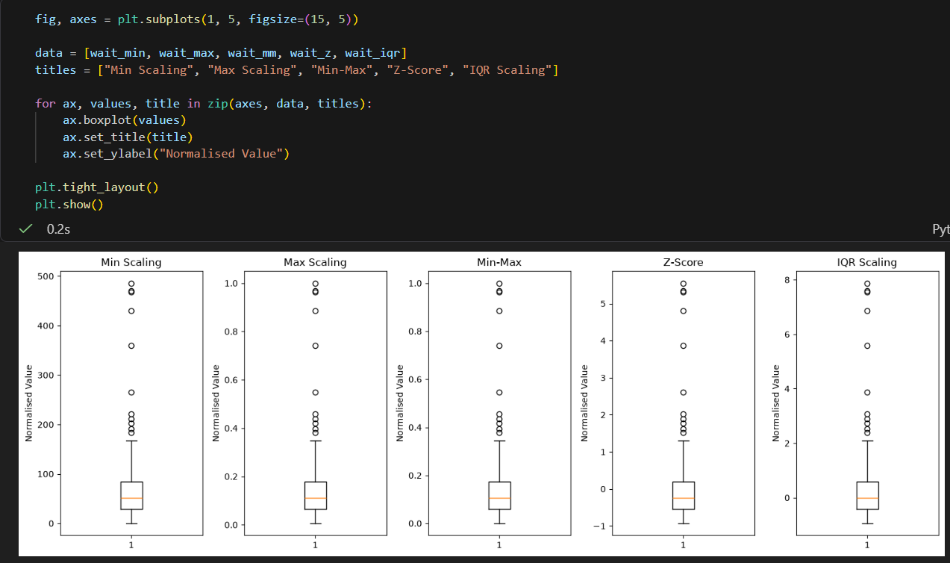

B20. In a final markdown cell, write a short paragraph (4–6 sentences) answering: for a machine learning model that is sensitive to the scale of features (e.g., K-NN), which normalisation technique would you choose for a dataset that contains outliers, and why? Mention at least two techniques in your comparison.
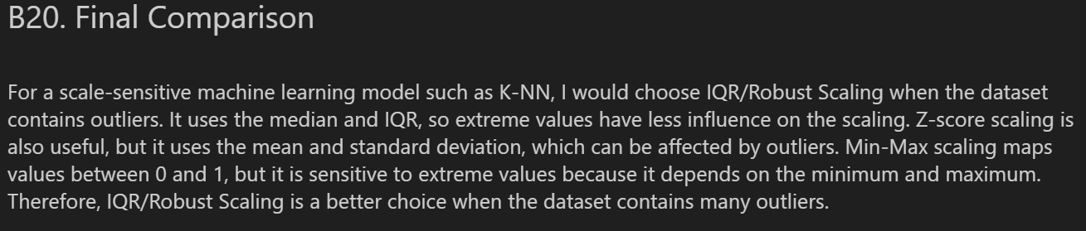
B.8 Take-Home (Submit with Notebook)
B21. Generate a new column: bimodal = np.concatenate([rng.normal(50,5,100), rng.normal(150,5,100)]). Apply all five normalisations to it. For each, draw a histogram. Which normalisation preserves the bimodal shape most clearly? Which technique would be misleading if you assumed the output was always unimodal?
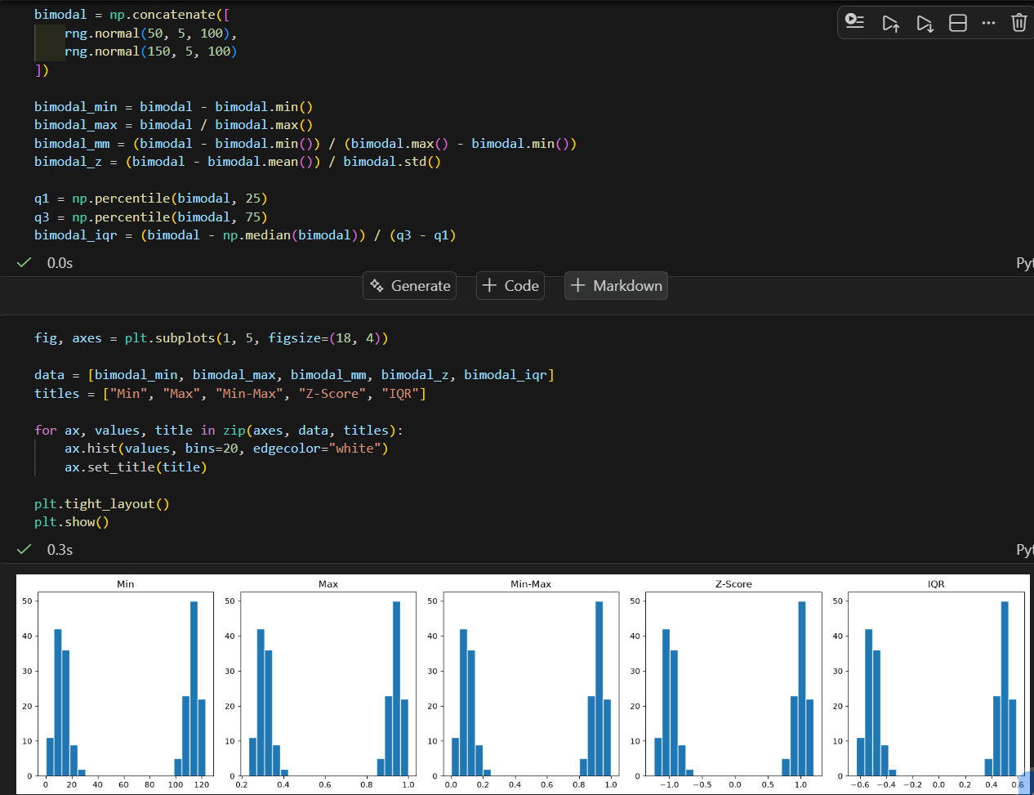
B22. Without using any pandas or NumPy normalisation helper: write your own functions min_max_scale(arr) and z_score_scale(arr) using only basic Python arithmetic. Verify that their output matches your earlier pandas results for the bp column (hint: np.allclose is useful here).
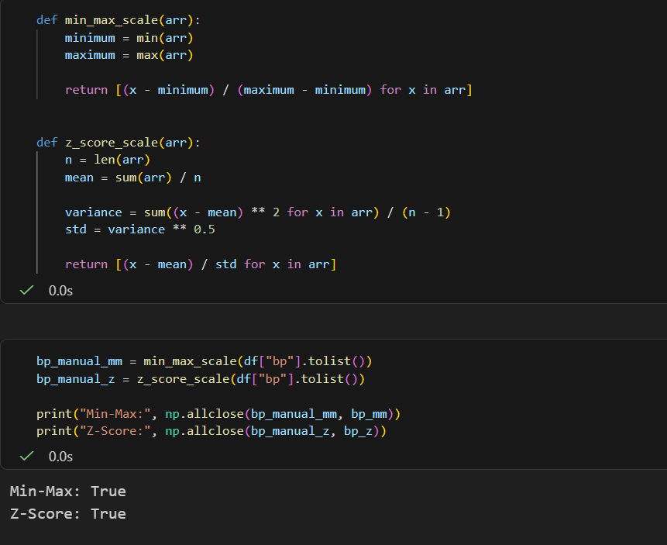
B23. Explore log transformation.


